Department of Peace and Nonviolence
Model Project
Domestic Activities

To support the Colorado Campaign

Requirements Definition Guidelines

(Precursor to Step 2)

Adapted directly from 3SL CRADLE Reference Material as a part of the software evaluation effort initiated Jan 2007
( http://www.threesl.com/pages/reference/index.php )

Table of Contents
Table of Contents 1
Requirements Definitions 3
Critical Requirements 3
Non-Critical Requirements 3
End User / Service Recipient Requirements 4
System Requirements 5
Requirements Capture 6
Requirements Audits 8
The Importance of Requirements 8
Getting the Right Requirement Right 9
Auditing Requirements 9
Requirement Audits and Cradle 10

Requirements Definition Guidelines
- Critical Requirements
- Non-Critical Requirements
- User Requirements
- System Requirements

Critical Requirements
A critical requirement is one that the Department (system) MUST include in its design if it is to be considered a successful Department (system).

The successfulness of the Department can be measured by monitoring / tracking key metrics or performance measures. Critical requirements and objectives are linked to these key performance measures.

Critical requirements and objectives are also used to identify deficiencies that jeopardize the ability of the Department (system) to meet its performance requirements.

Critical requirements are important because they are the criteria that drive the system solution that is created. If all the key stakeholders (Taxpayer, Voters, Congress, Executive Branch, DoPN, Partner Departments, Regional Offices of the DoPN, State & Local government agencies involved in various aspects of “peacemaking/peacekeeping”, local practitioners, as well as the key “Service Recipients”) must agree on a requirement, it is considered critical. Lack of agreement will become a future problem.

If the critical requirements are not both correct and agreed to, then the system development will be plagued with costly requirements changes, redesign, re-evaluation and verification and possible cancellation or withdrawal of support.
Identification of the critical requirements is extremely useful in interim progress reviews with key stakeholders as the Department evolves. Management, users and operators who do not want to know all of the technical detail may still want to know about progress on critical Department (system) functions.

To avoid project risk, remove requirements that represent uncertainty and high risk (probability or consequence).
- Avoidance includes trading off risk for performance or other capability, and it is a key activity during requirements analysis.
- Avoidance requires understanding of priorities in requirements and constraints. Is the requirement:
  - project critical?
  - project enhancing?
  - "bells and whistles?"
  - nice to have?

Critical requirements are traditionally expressed using the word "shall".

  - Non-Critical Requirements

A non-critical requirement is one that a system does not need to have in order to be considered a successful system.

Such a requirement is one that is not essential to the functionality of the developed system and that could be considered as "nice to have".

For example, supporting different languages. The system will work without supporting other languages, but language support would be a bonus.

Non-critical requirements are traditionally expressed using the word "should".

End User / Service Recipient Requirements
All levels of American society are considered end-users.
End Users / Service Recipients are affected by the Department in a variety of ways.
Service Recipients range from the President, to Congress itself, to partner Departments, to intranational organizations (i.e. business, educational institutions, faith-based organizations, State and Local government agencies, to families to individuals.
The role of Congress (the client) is to allocate taxpayer funds to pay for the development of the Department (product) and the role of the Executive Branch (customer) is to adopt, embrace, and operate the new Department of Peace for the End Users. The role of the Service Recipients (end users) is to apply the resources of the Department of Peace in their daily lives – to allow the Department to do its work (i.e. Peacemaking).
The DoPN Staff in conjunction with other partner Departments and local practitioners are the eyes and ears, as well as the arms legs and brains (the Operators) that make the Department work successfully for the Service Recipients. The DoPN operators and other support staff utilize the DoPN system to help End Users
a) reduce the levels in their life and
b) take advantage of opportunities for individual and collective growth

End Users exercise / utilize the Department/system for support, training, and functions associated with peacemaking.

End User requirements are the first step towards defining a system. Every system needs to satisfy its end users to be successful. It is important therefore to define who they are and what they want expressed in their own terms.

An end-user requirement is a requirement that needs to be implemented for the end user to be satisfied with the finished product.

User requirements are statements of fact as well as assumptions that define the expectations of the system in terms of mission or objectives, environment, constraints, and measures of effectiveness. They should be expressed in the terminology of the problem domain, defining what the users want to do with the system.

In other words, user requirements are defined from an operational point of view, not in terms of system functionality or equipment. They must be short and non-technical.

User and system requirements must be kept separate, with the former driving the latter. This often does not happen, and the requirements are often a single entity, mixing up user needs with box-drawings of the solution, background material, system functions, design elements and unverifiable wishes.

The diagram below shows how user requirements are defined,
1) start by defining the user types, and
2) capture requirements from each type.
a) structure these requirements into a coherent set,
b) review the requirements and get agreement by users, and
c) update, and publish a “User Requirements Document.”

It is essential to understand exactly what the users want from the Department (system).
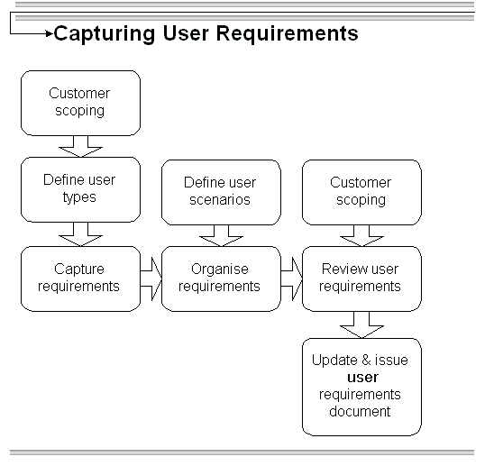

  - System Requirements

A Department (system) is an integrated composite of people, equipment, work products, and processes that provide a capability to satisfy a stated need or objective of the Stakeholders – particularly the End Users. System requirements are typically “derived from” User Requirements. For example, if the User has a requirement to “travel from home to the city,” we would create a system requirement such as “the system shall provide a means of transportation” Note that we did not immediately jump to a design solution such as “the system shall provide a car” because there are other system design options such a subway, taxi, bus, light rail, etc. The selection of the preferred design solution occurs later in the development process and involves some additional thought and consideration.

A system requirement is a requirement that a system must have to be a successful system. For example, hardware and environment requirements such as a camera that must be able to function in extremely cold conditions.

System requirements explore the solution, but ideally avoid commitment to any specific design. They show what the system will do, but not how it will be done.

System requirements contain both formal requirements and descriptive information.
They have several distinct uses:
- giving an abstract view of the system;
- allowing trade-offs, exploration and optimization before committing to design;
- demonstrating to users that their needs are reflected in the development;
- providing a solid foundation for design;
- providing a basis for testing the final system;
- Communicating previous decisions to developers.

The diagram below shows the overall process for defining system requirements.
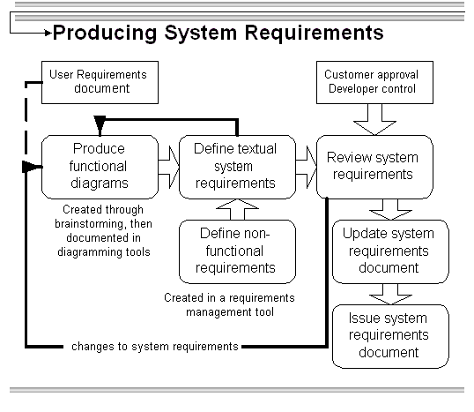

Requirements Capture
The requirements capture process involves assimilating documents received from external or internal sources, identifying individual need statements in them, and producing an initial set of requirements.

Currently there is only one official requirements document – the proposed bill entered into the 109th Congress. This Bill (e.g. S. 1756) provides a top level definition of the DoPN mission as well as its basic internal structure. The Bill also describes how the DoPN will interface with other federal Departments as well as State and Local government officials

Additional document will have to be “derived” by the developers – in particular the End User Requirements document. Each document formally received by a project is considered a source document whose content has to be analyzed. This analysis seeks to identify individual requirement statements, termed source statements, which will have to be addressed in the course of the project. Each source statement will be satisfied by, and cross referenced to, one or more formal requirements.

When received by a project, a source document must be registered into the systems engineering toolset in terms of items such as:
- Internal project name
- Document title
- Document issue number
- Document issue date

The document is then scanned to identify source statements. This scanning can be automated. It normally occurs on the basis of a paragraph-by-paragraph examination of the document, but is often done by searching for words such as:
- Shall
- must
- may
- will

It is likely that each paragraph in a source document will contain more than one source statement.

For each source statement (customer requirement) located, the scope of the source statement is identified in terms of a range of lines within the source document. One or more ranges of lines may be required to scope the source statement. Once the scope is defined, the source statement (customer requirement) can be examined and possibly captured into the project database.

Examination of the source statement occurs on a project-specific keyword basis using a glossary created for the project and maintained during its life. We have created a list of “key issues” that are called out in the Legislation. This can serve as the initial “data dictionary” / glossary. The contents of the glossary can be used to scan the requirements set to identify any existing requirements that relate to the source statement. This process identifies instances where more than one source statement is to be satisfied by a single requirement.
In such instances, the text of the pre-existing requirement can be amended to reflect the current source statement. This will be an automated process within the systems engineering toolset in which:
- The text of the source statement is optionally appended to a specific component of the existing requirement to provide a starting point for further editing
- A cross reference between the source statement and the requirement is created

In the situation where a pre-existing requirement does not exist for the source statement, a new requirement must be generated. This will be an automatic process within the systems engineering toolset in which:
- A new requirement is created
- The text of the source statement is optionally copied to a specific component of the new requirement to provide a starting point for further editing
- A cross reference between the source statement and the requirement is created

This process repeats until the entire source document has been scanned.

It is important that a clear distinction is drawn between the paragraph numbers in the source document and the numbers associated with the generated requirements. The paragraph numbers are merely a side effect of the section and subsection structuring of the source document. They may have no other meaning, especially if the customer is content for paragraphs to be renumbered as new issues of the source document are produced.

As a result, it is recommended that requirement numbers have a format different from the paragraph numbers of their source statements. Unless there is good reason to the contrary, a simple numbering scheme 1, 2, 3 ... should be used, potentially hierarchical in nature, grouped by Subject or major system area, and decomposed with levels of decomposition of the requirements as they are engineered.

New issues of source documents should be compared with the previous issue as a first step in the analysis of subsequent versions of the source document. This process should also be automated in the systems engineering toolset and will identify additions, changes, and deletions in the source document's text.

For each addition, one or more new requirements will be generated, as previously described. For changes and deletions, the toolset should identify the source statements within whose scope the change or deletion has occurred, and the requirements associated with these source statements. It is then a matter for the project to determine the manner in which the amendment to the source document should be reflected in these associated requirements, in terms of:
- Deletion of the requirement(s)
- Amendment of the requirement(s)
- Creation of new requirement(s)

If the requirement set has been registered into a formal project baseline, then one or more Change Requests (CHRs) and Change Tasks (CHTs) must be raised to implement the actions resulting from these deliberations.

At any time, the systems engineering toolset should allow the production of a traceability report between the source statements in a source document and the requirements set, and vice versa.

Requirements Audits

The Importance of Requirements

Requirements form the backbone of any successful project, setting the scope for all subsequent work and providing the measure of success or failure.
- Owner, operator, and end-user requirements define stakeholders' needs.
- System requirements define the functional and non-functional aspects of the system that will realize this need.

If these requirements are wrong or misinterpreted, there will be confusion, the product will not meet the stakeholders' expectations, resources will be wasted, and the project /Department could failing[1]. When creating a new system, it is estimated that 70% of project costs are committed before full scale development starts[2], it is easy to see why the costs of correcting mistakes after production can be 100 times the cost of getting the requirements right.

Getting the Right Requirement Right

Considerable effort can be expended in capturing and managing requirements - getting the right requirements. However, if the right requirement is misinterpreted, is not related to other requirements or is incomplete, the content will be lost and the requirement will fail. Requirements engineering employs systematic and repeatable techniques to ensure requirements are complete, consistent and relevant - getting the right requirement right. Requirement engineering mitigates the risk that the project will fail because the requirements are incomplete, will be misinterpreted or are incorrect.

Auditing Requirements

A requirement-engineering based audit identifies strengths and weaknesses, giving guidance to focus limited resources in developing a robust and agreed set of requirements.

It is an objective review, providing a project and domain independent perspective at any stage in the life cycle to give confidence in the requirements. A requirement audit analyses several criteria using a variety of techniques at the levels of the individual requirement and of the whole requirement set:

Criteria | Description | Audit Technique
Ambiguity | Consistent and defined use of natural language words, phrases and domain-specific terminology. Can readers from diverse backgrounds interpret the requirements? | Create dictionary and link definitions to each requirement.
Clarity | The requirement is written clearly, precisely, and without using complex conditional phrases. | Objective and subjective review. Introduction of standard templates or boilerplates and atomized statements. Grammatical & natural language analysis.
Correctness | Each requirement has the set of attributes required by a corporate process or recognized guidance, or has adequate information to express a correct requirement. | Define agreed requirement model and compare. Numerical analysis of blank/incomplete attributes to generate metrics
Completeness | The system requirement contains all necessary functions. All functions should have an input coming from either another function or from an external entity, and every output should go to another function or to an external entity. | Create functional and object-oriented models and hierarchy diagrams to illustrate and explore internal relationships between requirements. Check for consistency of input and output and identify gaps or excessive requirements.
Coverage | Each statement should be cross-referenced with or linked to a superior statement, demonstrating top-down derivation. Each user requirement should be linked to a source or justification, each system requirement must be derived from one or more user requirements, and each user requirement is being delivered by one or more system requirements. | Traceability matrix.
Consistency | No duplication, redundancy or contradiction between individual requirements. Requirements should be mutually consistent. | Interaction matrix and requirement model to analyze functional inputs and outputs.
Structure | Are the requirements organized in a sensible way, and are related requirements grouped? Has the requirement structure been decomposed consistently and completely? | Hierarchy and object oriented modeling to analyze decomposition.
Testable | Does each requirement have defined and realistic acceptance/verification criteria? | Analysis of acceptance criteria and mapping to acceptance events.
Priority | Are requirements prioritized? Is the priority cascaded correctly? | Basic QFD analysis.

Requirement Audits and Cradle

A comprehensive requirements audit is recommended. Following an initial study, the requirements and all supporting documentation are imported and analyzed using built-in cross-referencing, matrix generation and modeling tools. The results can be provided as a formal audit report describing the method employed, the results and any recommendations for improvement. Implement agreed recommendations and return the modified requirements in the original data format with full justification for all changes. The result is an increased confidence in the requirements based on external, objective analysis.

The outputs of the techniques employed during a requirements engineering audit can also be re-used by other activities. A simple model developed to analyze completeness and consistency can facilitate further requirement capture where gaps exist, provide the basis for functional allocation and architecture design, or be used to identify external and internal interfaces. The identification and calculation of relevant metrics can be used as a management control, the audit providing a baseline against which to set targets and monitor progress.

[1] Incomplete requirements account for 13.1% of projects failing (Standish Group 1995 & 1996)
[2] "Engineering Design of Systems" (Dennis Buede, 1999)

